Astronomical Constants

Astronomical Unit AU = 1.496 x 10¹¹ m

Parsec pc = 206,265 AU
= 3.26 ly
= 3.086 x 10¹⁶ m

Light year ly = 6.324 x 10⁴ AU
= 0.307 pc
= 9.46 x 10¹⁵ m

Sidereal year 1 year = 365.26 days
=3.16 x 10⁷ s

Mass of Earth M⊕ = 5.98 x 10²⁴ kg

Radius of Earth R⊕ = 6378 km
at equator

Orbital velocity V⊕ = 30 km/s
of Earth

Mass of Sun M = 1.99 x 10³⁰ kg

Radius of Sun R = 6.96 x 10⁵ km

Luminosity of Sun L = 3.90 x 10²⁶ W

Effective temp T_{eff} = 5780 K
of Sun

Mass of Moon M_{Moon} = 7.3 x 10²² kg
= 0.0123 M⊕

Radius of Moon R_{Moon} = 1738 km
= 0.273 R⊕

Radius of Moon’s d_{Moon} = 3.84 x 10⁵ km
orbit

Sidereal month P_{Moon} = 27.3 days
Synodic month = 29.5 days

Distance of Sun R₀ = 8.5 kpc
from Galaxy center

Velocity of Sun V₀ = 220 km/s
aboutGalactic center

Diameter of Galaxy = 50 kpc

Mass of Galaxy M = 7 x 10¹¹ M

Physical and Mathematical Constants

Velocity of light c = 3.00 x 10⁸ m/s

Gravitational const. G = 6.67 x 10⁻¹¹ N m²/kg²

Planck constant h = 6.626 x 10⁻³⁴ J s

Boltzmann constant k = 1.38 x 10⁻²³ J/K

Rydberg constant R = 1.097 x 10⁷ m⁻¹

Stefan-Boltzmann σ = 5.67 x 10⁻⁸ W/(m² K⁴)
Constant

Wien’s Law const. λ_{max}T = 2.898 x 10⁷ Å K

Mass of hydrogen m_{H} = 1.67 x 10⁻²⁷ kg
atom = 1.0078 amu

Mass of helium atom m_{He} = 4.0026 amu

Mass of electron m_{e} = 9.11 x 10⁻³¹ kg

Charge of electron e = 1.60 x 10⁻¹⁹ C

Electron volt 1 eV = 1.602 x 10⁻¹⁹ J

π = 3.1416

e = 2.7183; log₁₀e = 0.4343

Atomic mass unit amu = 1.660539 x 10⁻²⁷ kg

Proton mass m_{p} = 1.007277 amu

Neutron mass m_{n} = 1.008655 amu

Kepler’s Laws

(1) The orbit of each planet is an ellipse with the Sun at one focus.
(2) The radius vector to a planet sweeps out equal areas in equal intervals of time.
(3) The squares of the sidereal periods of the planets are proportional to the cubes of the semimajor axes of their orbits.

a ae
a
a
b

Newtonian Physics

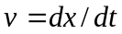
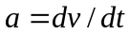
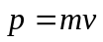
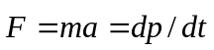
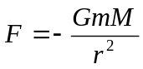
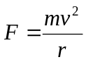 (for circles)
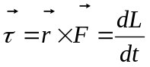
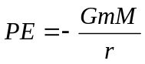
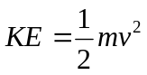
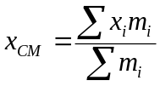
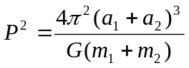
Electromagnetic Radiation

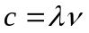
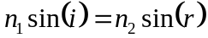
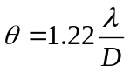
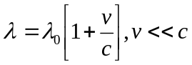
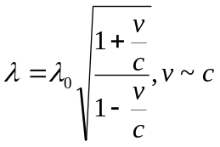
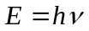
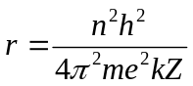
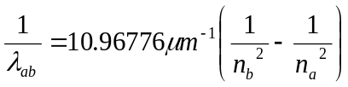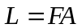

Blackbody Radiation
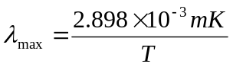
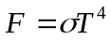
Properties of Planets

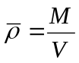
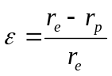

Atmospheres

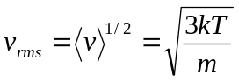
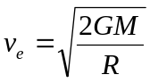

Tidal Forces

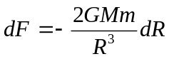
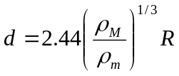

Stellar Structure

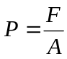
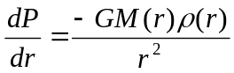
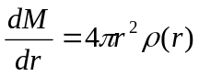
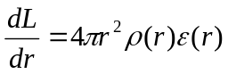
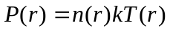
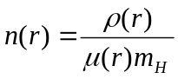
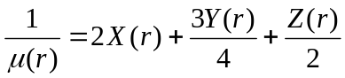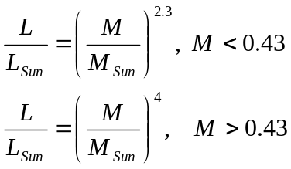
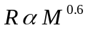

Viral Theorem

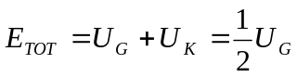
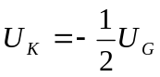

Magnitudes & Distances

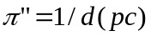
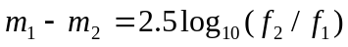
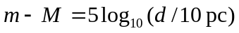
Color Index = m(λ₁) – m(λ₂)

Variable Stars

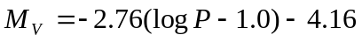 (period in days)

Stellar Counts
log N(m) = 0.6m + C
(const. density, single abs. mag.)

Redshift
z ≡ (λ-λ₀)/λ₀
≈ v/c for small z

Hubble’s Law
v = H₀d

Large z, flat Universe
d = cz(1+z/2)/[H₀(1+z)²]

Nova peak magnitude
M_{V}^{max} = -9.96 – 2.31 log(m)

Black Holes
R = 2GM/c²
= 3M km (M in M)

Cosmology
